IWS organization guide
Fall semester 2022-2023 academic year year
on the educational program «PHYSICAL CHEMISTRY, II»
IWS-1 Chemical kinetics
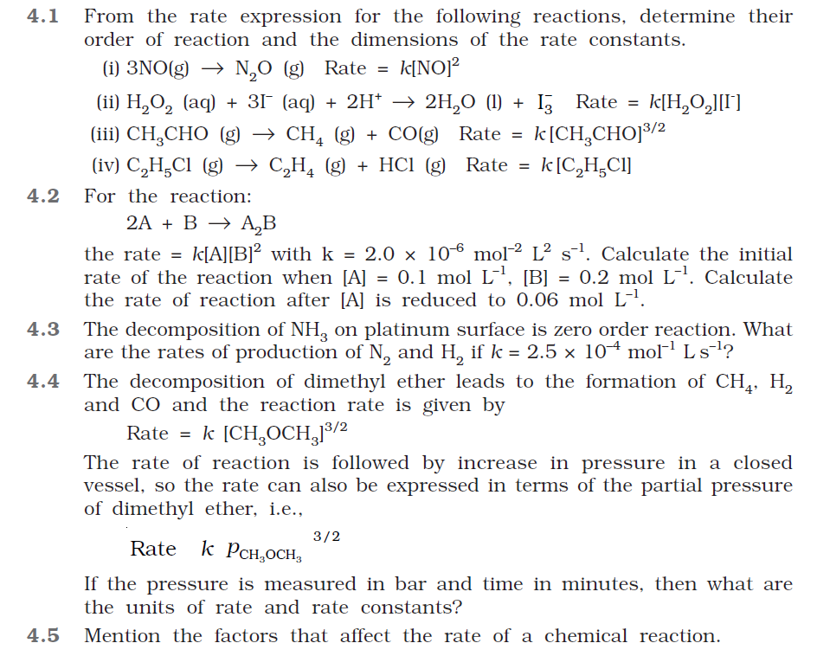
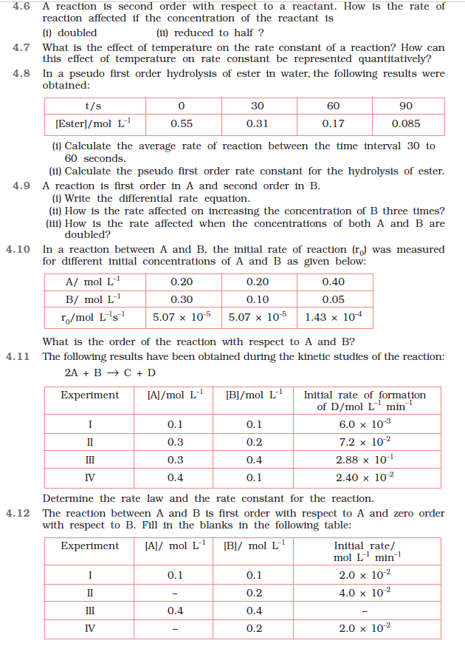
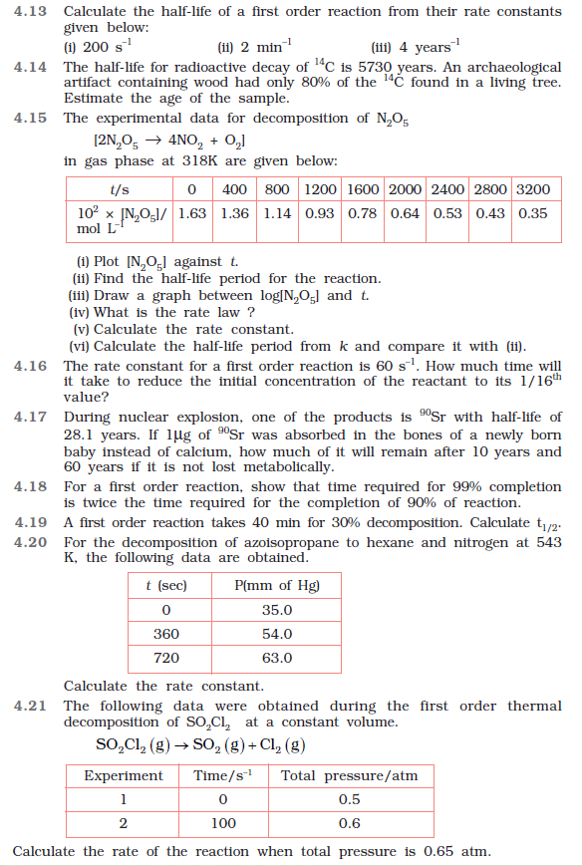
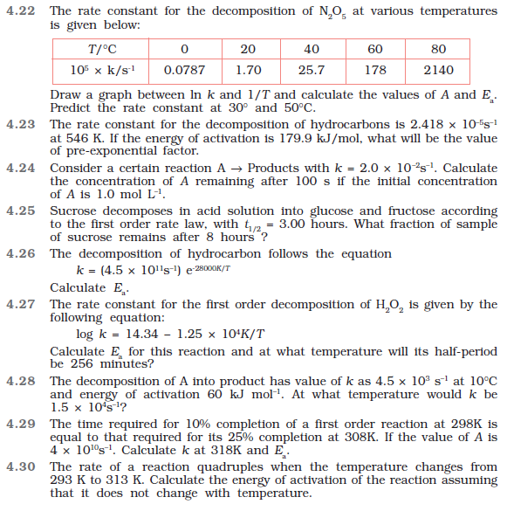
IWS-2 Electrochemistry
1. What are the branched chain reactions? Explain why the overall reaction rate of branched chain reactions depends on the ratio of K₁ and K₂.
2. Modes of electrochemical reactions. Rate of the electrochemical reaction in kinetic mode.
3. What are the photochemical reactions? On what laws is photochemistry based?
4. Formulate the possible reactions depending on the ratio of the branching and chain termination (N.N. Semenov).
5. What are the electrochemical reactions? What are the differences between electrochemical reactions from chemical reactions?
6. Derive the formula for finding the overall reaction rate of branched chain reactions.
7. Define electrochemical circuits and their types. What is the galvanic cell?
8. Derive the formulas for finding the reaction rate of an electrochemical reaction in kinetic mode.
9. Concentration circuits without transfer of first and second kind.
10. Define the characteristics of electrochemical polarization. Tafel equation.
11. What is an electrochemical system? Give its features.
12. Define quantum yield. Explain the types of photochemical reactions depending on the value of quantum yield.
13. Formulate the thermodynamic characteristics of a galvanic cell.
14. Define the processes of photochemical reactions?
15. Derive the formulas for finding reaction rate of electrochemical reaction in kinetic mode.
16. What are electrode potential and electromotive force (EMF)? Provide the formulas for finding the electrode potential and EMF of a galvanic cell.
17. Characteristics of concentration polarization.
18. Electrode polarization and its types.
19. Modes of electrochemical reactions. Rate of the electrochemical reaction in kinetic mode.
20. Explain the types of electrode polarization by the nature of limiting stage of an electrode process.
21. ΔH of the reaction Pb + 2AgCl = PbCl₂ + 2Ag occurring in a galvanic cell is –105.1 kJ⋅mol^{–1}. The EMF of this element is 0.4901 V at 298.2 K. Calculate the EMF of the element at 293.2 K.
22. The EMF of the element in which the reaction 0.5 Hg₂Cl₂ + Ag = AgCl + Hg reversibly proceeds is 0.456 V at 298 K and 0.439 V at 293 K. Calculate ΔG, ΔH and ΔS of the reaction.
23. The reaction of photochemical bromination of ethane proceeds according to the following mechanism:
Br₂ + hν → 2Br., I
Br. + C₂H₆ → HBr + C₂H₅., k₁
C₂H₅. + Br₂ → C₂H₅Br + Br., k₂
Br. + Br. + M → Br₂ + M, k₃ (termination in a volume)
Br. → 1/2Br₂, k₄ (termination on a wall).
Determine the rate of formation of bromoethane, assuming that the termination occurs only:
a) in a volume;
b) on the wall.
24. Calculate the quantum yield of the photochemical reaction (CH₃)₂CO → C₂H₆ + CO proceeding under the action of UV light with a wavelength of 313 nm. Initial data: the volume of the reaction vessel is 59 mL; the average amount of absorbed energy is 4.40⋅10^{–3} J⋅s^{–1}; exposure time is 7 h; reaction temperature is 56.7 °С; initial pressure is 766.3 Torr; final pressure is 783.2 Torr.
25. EMF of a galvanic cell Pt | Q⋅QH₂ | buffer solution | Hg₂Cl₂ | Hg is equal to 4.2 mV at 25 °C. When the original buffer was replaced with another one, the polarity of the element and the EMF value changed: E = –21.75 mV. Calculate the pH of both buffer solutions.

